For men | https://lucho.com/for-men/ | mens suits near me  mens suits houston  men's clothing houston  men's wear houston  suits for men houston

https://lucho.com/for-men/
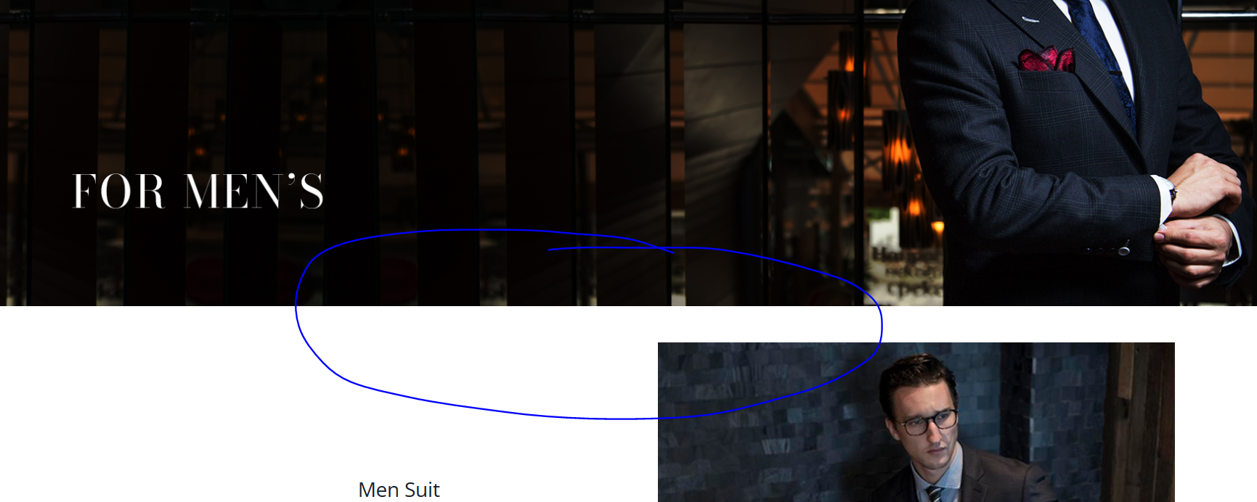

Men's Wear in Houston (h1)
Take a step toward elegance with Lucho – the best men’s wear in Houston store. We have an extensive collection of suits, sports coats, shirts, trousers, ties, cufflinks, pocket squares, outerwear, and shoes for all occasions. Upgrade your style and get the outstanding shopping service at our men's suits near me store in Houston. Buy from our selected collection and turn heads high in every celebration you attend.

This paragraph will appear below the banner.

